**Picture 5**

*EMBARGOED FOR RELEASE:*

*July 20, 2020, 6 AM EST*

**CONTACT:**

Sean McElwee  
Co-founder and Executive Director | Data for Progress

[sean@dataforprogress.org](mailto:sean@dataforprogress.org)

**Warren, Harris Top Poll of Battleground Independents for Biden VP**

Poll: Warren strongly favored by lower-income, unemployed voters and those still unsure about Joe Biden

Harris favored by voters who earn more than $150,000 a year

**NEW YORK, NY** — **A poll of Independent voters in battleground states reveals significant differences in income and confidence in Biden among unaffiliated voters who support Elizabeth Warren and Kamala Harris as top choice for vice president.**

The poll of 538 Independent voters living in twelve battleground states, including Arizona, Florida, Georgia, Michigan, North Carolina, and Wisconsin, was fielded by Data for Progress and YouGov Blue. The July 2020 poll included a variety of questions gauging battleground state voters’ views of the vice presidency and their views on who Joe Biden should choose as his running mate.

While many Independents are undecided, those with an opinion are currently split between Senator Elizabeth Warren (D-MA) and Senator Kamala Harris (D-CA) as the preferred vice-presidential nominee, with no other potential nominee breaking 5 percent. Among Independent voters who report they currently do not lean toward either party, Senator Warren is the first or second choice of 23 percent of those voters, and Senator Harris is the first or second choice of 21 percent. UNCLEAR. SUGGEST WE CUT: with Warren at 11 percent first choice and Harris at 11 percent of first choice. Among all independents, the results are also statistically tied.

“Most of Senator Warren’s strongest support comes from voters in households that earn under $60,000, less than the median income,” says John Ray, Senior Political Analyst of YouGov, which conducted the poll for Data for Progress. (The median household income for 2018 as reported by the U.S. Census Bureau was $63,179.) The poll further revealed that 18 percent of Independent voters from households earning less than $30,000 say Senator Warren is their first choice for vice president, compared with 11 percent for the next nearest candidate, Keisha Lance Bottom. Just 5% of those surveyed with family income of under $30,000 say they support Senator Harris for vice president.

In contrast, Senator Harris is received five times more support, or 26 percent, from voters in households that earn more than $150,000 a year. “Most of Senator Harris’s support,” Ray says, “comes from voters with a family income of more than $70,000, above the median family income.”

Similarly, Senator Warren is the preferred candidate among Independent voters who reported they were unemployed. Fully 16 percent of unemployed Independent voters supported Senator Warren, with no other candidate earning over 5 percent of this group. The choice among Independents who are employed full time is narrowly split between Senators Warren and Harris (13 percent to 11 percent).

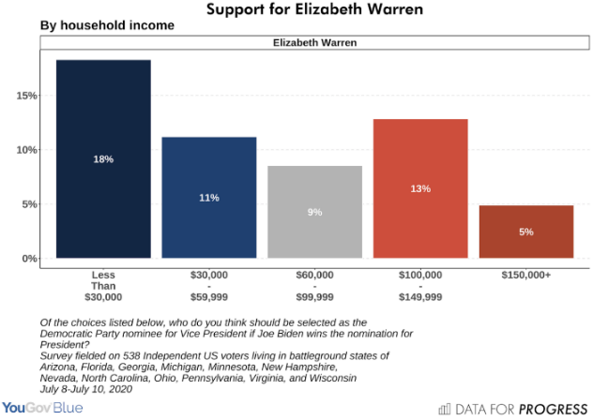

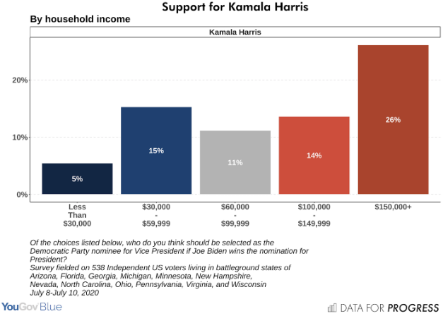

Senator Warren leads Senator Harris 4-to-1 among voters unsure about Biden but who think his pick for vice president is important: About 21 percent of those voters would prefer Senator Warren to be the nominee for vice president, with Senator Harris trailing at 5 percent.

“Among battleground-state persuadable voters who are unsure about voting for Biden, Elizabeth Warren is the first choice for vice president,” says Sean McElwee, Co-founder and Executive Director of Data for Progress.

**HIGHLIGHTS FROM THE POLL INCLUDE:**

* Of those voters who are currently dissatisfied with the idea of voting for Biden but report they would consider voting for him, 26 percent support Senator Warren as their top vice presidential nominee, far higher than all other choices.

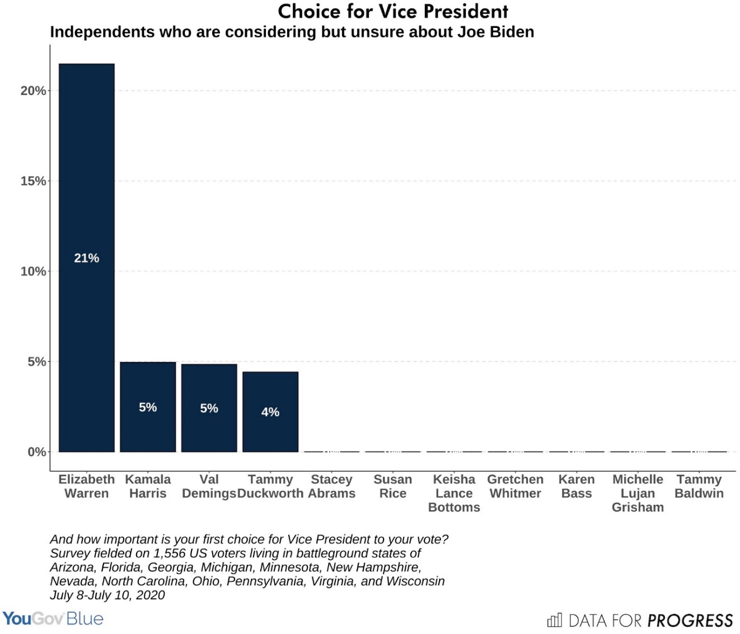

* Among Independent voters who report they currently do not lean toward either party, Senator Warren is the first or second choice of 23 percent of voters, and Senator Harris is the first or second choice of 21 percent.
* REWORDED SOME OF THIS. PLEASE CHECK. Most of Independents surveyed who say Senator Warren is their first choice for vice president earn less than the median family household income. Fully 18 percent of her support is from voters in households earning less than $30,000 a year. By contrast, the poll shows only 5 percent of Senator Harris’s first-choice support comes from these housholds. Twenty-six percent of Senator Harris’s first-choice support comes from voters in households with more than $150,000 per year in income. The next candidate among higher-income households, Illinois Senator Tammy Duckworth, receives 12 percent of their first choice support.
* Independents want the vice president’s ability to handle the economy to be the top issue guiding Biden’s choice of a vice president. Independents rank Senator Warren most effective on the economy by more than 3-to-1. ([See release issued July 17, 2020.](https://www.prnewswire.com/news-releases/battleground-survey-finds-independent-voters-cite-handling-of-economy-as-top-issue-to-guide-biden-vp-choice-301095497.html))
* More battleground-state Independents rate Senator Warren as the most effective president on day one if called to serve. Biden has noted that readiness to serve as president on day one is critical to his choice for vice president. ([See release issued July 17, 2020.](https://www.prnewswire.com/news-releases/battleground-survey-finds-independent-voters-cite-handling-of-economy-as-top-issue-to-guide-biden-vp-choice-301095497.html))

READ THE FULL BLOG:  <https://www.dataforprogress.org/memos/battleground-poll-results-of-independents-employment-income>

**About Data for Progress**

Data for Progress is a trusted public opinion research organization and multidisciplinary group of experts using state-of-the-art techniques in data science to support progressive activists, and causes. We provide voter file analysis, digital communications, polling, policy development, and message guidance.

For more information, please contact: Sean McElwee (sean@dataforprogress.org)

**About YouGov Blue**

YouGov Blue is a division of YouGov serving Democratic and progressive clients. Leveraging YouGov’s panels, methodology, and technology infrastructure, we are pioneering novel capabilities and strategies. YouGov Blue’s online survey tools, polling experience, and digital environment allow us to provide a unique suite of products to help our clients achieve their goals. We work with think tanks, interest groups, unions, candidates, and analytics and polling firms to help them gain insights from online surveys. We provide services for all stages of the survey research process, including questionnaire design, sampling design, survey fielding, weighting, reporting, and analysis. We are matched to the major voter files and have expertise in using voter files to enhance survey analysis. Our team combines academic and political experience to ensure that our practice is grounded in both methodological rigor and the needs of our clients. For more information, please contact: John Ray ([john.ray@yougov.com](mailto:john.ray@yougov.com)).

SOURCE: Data for Progress.